# **Compte-rendu VPN**

Task 1: Configure IPsec parameters on R1

Step 1. Test connectivity.

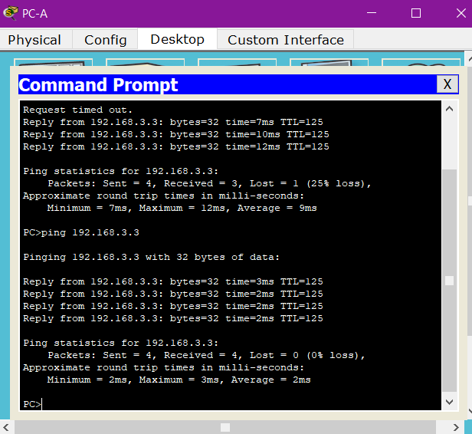

Step 2. Identify interesting traffic on RI.

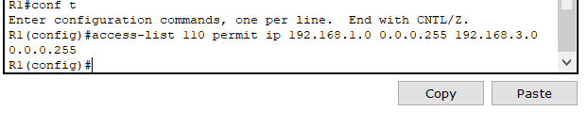

Step 3. Configure the ISAKM P Phase 1 properties on R1.

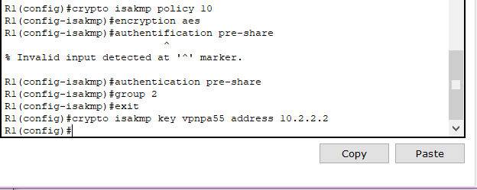

Step 4. Configure the ISAKMP Phase 2 properties on R1.

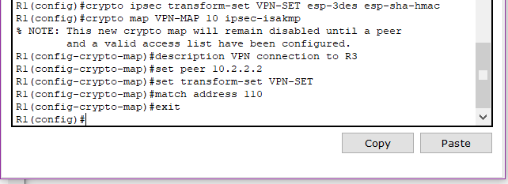

Step 5. Configure the crypto map on the outgoing interface.

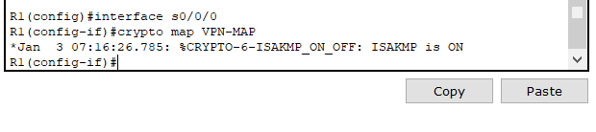

## Task 2: Configure IPsec Parameters on R3

Ste p 1. Configure router R3 to support a site-to-site VPN with R1.

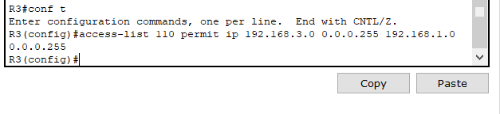

Step 2. Configure the ISAKM P Phase 1 propercies on R3.

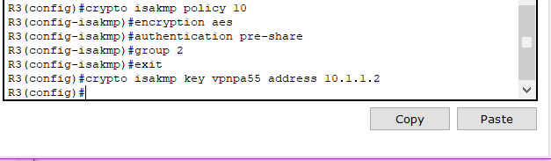

Ste p 3. Configure the ISAKM P Phase 2 properties on R1.

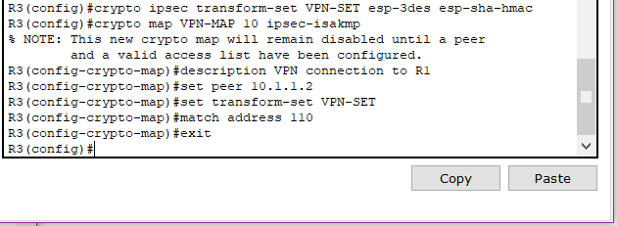

Ste p 4. Configure the crypto map on the outgoing interface.

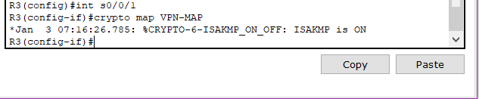

Task 3: Verify the IPsec VPN

Ste p 1. Verify the tunnel prior to interesting traffic.

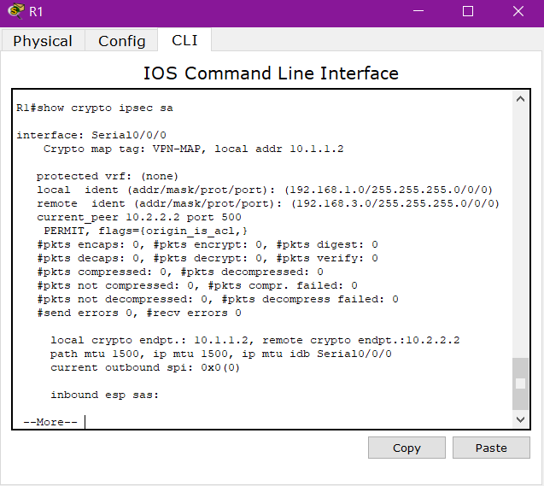

#### Step 2. Create interesting traffic.

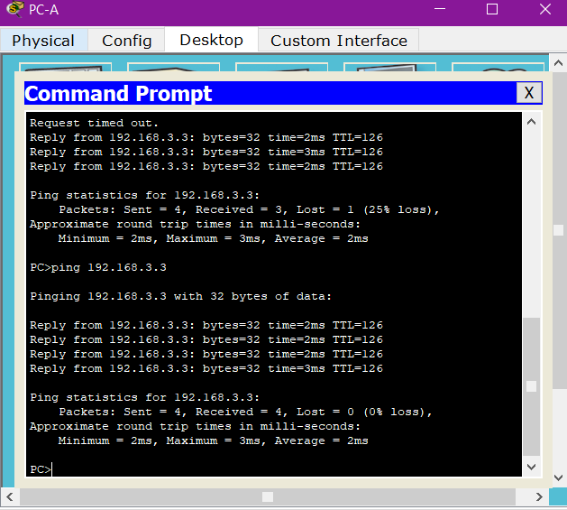

Ste p 3. Verify the tunnel after interesting traffic.

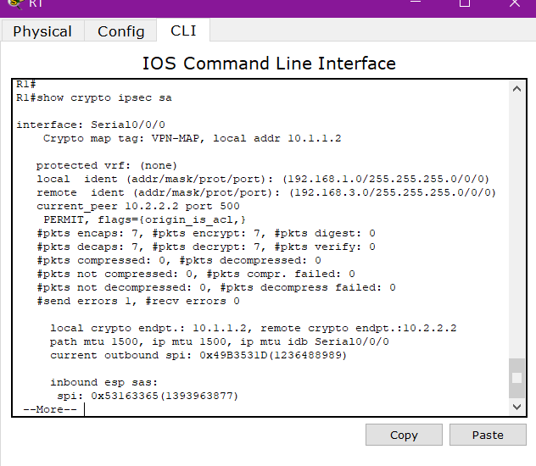

Ste p 4. Create uninteresting traffic.

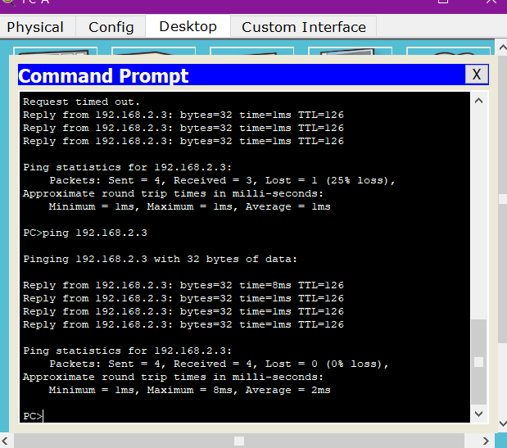

Step 5: verify the tunnel



Step 6: Check results

